Moch. Marsa Taufiqurrohman
University of Jember
Jember, East Java, Indonesia 68121

November 23, 2020

Dear Editor of Jurnal Konstitusi,

I am pleased to submit an original research article entitled “Integrasi Sistem Peradilan Pemilihan Umum melalui Pembentukan Mahkamah Pemilihan Umum” for consideration for publication in Jurnal Konstitusi.

This manuscript considers an insight into how to how to improve the electoral justice system in Indonesia. Elections that do not end only in counting votes, and instead have to be resolved in the judiciary, have unwittingly become a measure that can legitimize and assess the quality of democracy. This situation confirms that the existence of a judicial institution has become an important part of the sustainability of the election process. This manuscript tries to re-evaluate the implementation process of the Election justice system in Indonesia. These problems include the tug of war over regional head election dispute resolution, disintegration and overlapping authority for resolving general election disputes, the accumulation of Election disputes in the Constitutional Court, as well as problems regarding recall system for DPR members by political parties.

Our manuscript uses doctrinal normative legal research collaborated with the Reform Oriented Research method. In resolving these problems, this manuscript offers an idea in the form of integrating the entire Election dispute resolution process in a Supreme Election Court. The Supreme Election Court will be positioned parallel to the Constitutional Court and Supreme Court. The Supreme Election Court has the authority to judge at the first and last levels whose decisions are final and binding to decide on violations of the code of ethics of Election administrators, violations of Election administration, election process disputes, election crimes, over results disputes and post-election disputes.

This manuscript has not been published and is not under consideration for publication elsewhere. We have no conflicts of interest to disclose. If you feel that the manuscript is appropriate for your journal.

Thank you for your consideration!

Sincerely,

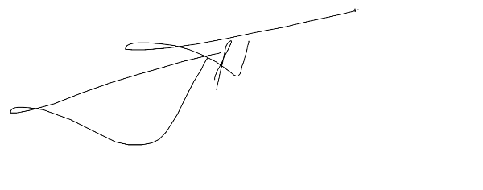

Moch. Marsa Taufiqurrohman

